John Szostak

**Nojima, Yasuzô (野島康三 1889-1964)**

Nojima Yasuzô, born Nojima Hiromasa, was a central figure to Japanese modern photography and to the development of Japanese artistic modernism in general. His photographic style were instrumental in the refinement of two aesthetic movements in Japan, namely, pictorialism (*kaigashugi shashin*), which was imported from Europe in the late nineteenth century and remained influential through the 1920s, and “new photography” (*shinkō shashin*) in the 1930s. Nojima’s early style in the 1910s and 1920s reflects the painterly concerns of pictorialism, favoring poetic landscapes and sensitive portraits produced with heavy pigment printing.  In the 1930s, inspired by the trends in German photography, Nojima’s photos became increasingly spontaneous and experimental, with nudes and portraits becoming increasingly his subject of choice, with his female subjects showing what Luisa Orto described as “a heaviness and earthiness that was far removed from standard traditions of Japanese feminine beauty.” Besides his photographic output, Nojima was also involved in the founding of the seminal art photography journal *Kôga* (*Pictures of Light*) in 1932, and in the creation of a photography section of the juried exhibition society Kokugakai in 1939.

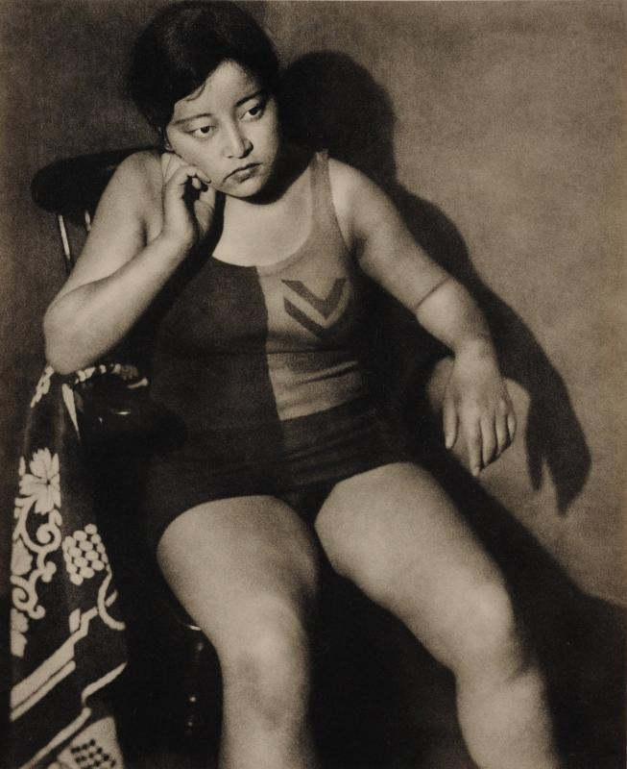

Nojima Yasuzô, *Model F*, 1931. Bromoil print. National Museum of Modern Art, Kyoto. Link: <http://search.artmuseums.go.jp/search_e/records.php?sakuhin=183517>.

Nojima was born in the city of Urawa, Saitama prefecture. His interest in photography began in 1906, when he was a student at Keiô University, and he then left university in 1909 to devote himself entirely to photography. In 1912 he joined the Tokyo Photographic Research Society (Tokyo Shashin Kenkyûkai), where he frequently won awards in the society’s juried exhibition, the Kenten. 1915, he opened a photography studio in Tokyo, and in 1919, he started one of Japan’s earliest and most influential commercial art galleries, Kabutoya Gado, where he held exhibitions and promoted both photographers and painters, especially Umehara Ryûzaburô, Kishida Ryûsei, and others associated with the Shirakaba (White Birch) movement.

Nojima’s photographs from this time focused on figures and landscape in the painterly, lyrical pictorialist mode. His work was not without controversy, however, as demonstrated in 1920, when police confiscated three of Nojima’s female nude photographs from the Kenten exhibition on the grounds of obscenity. His style changed after 1931, the year the exhibition *Film und Foto* opened in Tokyo, which introduced trends in photography then being explored in Europe. This exhibition led to many photographers in Japan to break from pictorialism and to embrace a more experimental, spontaneous style. In Nojima’s hands, this “new photography” (*shinkô shashin*) remained focused on the portrait and the nude figure, but he selected unusual models, posed them less conventionally and often more sensually, and framed his photographs in ways that cropped or distorted his models’ bodies and features. Nojima’s 1933 solo exhibition, “The Woman’s Face in Photography: Twenty Photographs,” was particularly influential, and helped establish him as one of Japan’s premier modernist photographers.

**Further Reading:**

Charrier, Philip. (May 2006) "Nojima Yasuzō's Primitivist Eye: 'Nude' and 'Natural' in Early Japanese Art Photography," *Japanese Studies*, Vol. 26, No. 1, 47-68.

Orto, Luisa. (2003) “Nojima Yasuzô,” in *The History of Japanese Photography*, edited by Anne Tucker, New Haven, CT: Yale University Press, 355.